TESTING PUSH NOTIFICATION

1. Install the latest build and track some orders
2. Login to Parse
3. Go to Dashboard
4. Choose Rogue-Fitness > Core
5. Select Installation table in Data
6. Change **status** in **trackorders** column of the device which will receive push

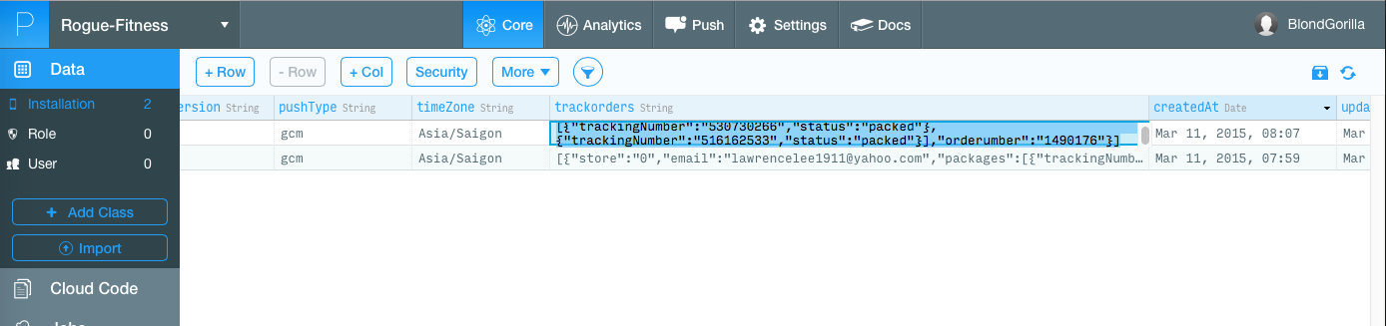

In this example, I changed **status** from **delivered** to **packed**

1. Go to Jobs and choose Run Now

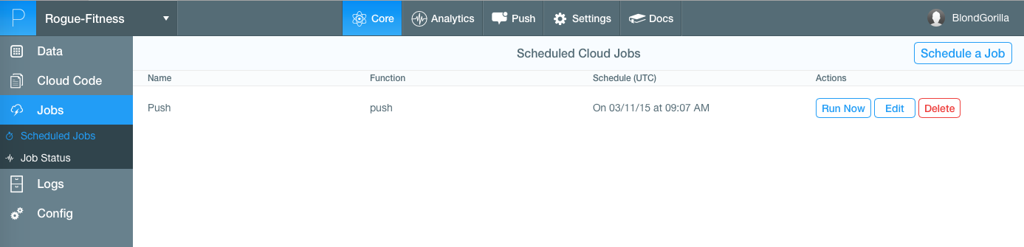

And then wait for push message appear in devices which their order status being changed.

(In actual circumstances, we will schedule the script so it will run automatically)